Title or Task: | Multimedia  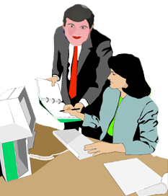
Description: | This task is in two parts COREL or FLASH
Files Required | Camera, Microphone
Suitable for Classes: | Multimedia / Digital Media or Design
Area: | Technology & Enterprise
Teacher: | Mr Peter Faulks
Marks: | Worth: 20% | Weighting: 20%
Date Due: | Late penalty 5 marks plus 2 marks per day thereafter
Task Brief: | Create a talk welcome to multimedia
Outcomes: | Investigation : Devising : Producing : Evaluating

Items highlighted in yellow are tasks for you to complete
Items in Purple are help tips

UNIT: Multimedia
TASK 2: Jaw Talk (100 marks)
Task
6
1. Make your jaw talk…(Using Rave & Audacity)
2. Make your jaw talk…(Using Photoshop & Flash) see below
What you need to do:

Use Paint to bring in a photograph of yourself,

Save this as jaw1.jpg

Use the free form select tool to select a part of your jaw.

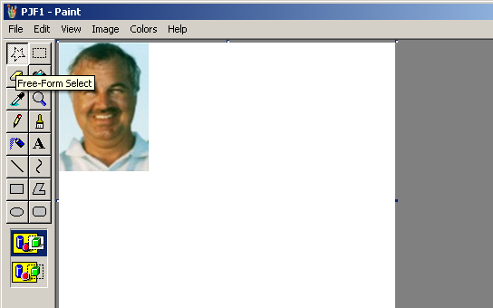

Drag this down and fill the gap with black or a dark pink or grey

Save this as jaw2.jpg

Repeat bringing the jaw down further (use the same fill)

Save this as jaw3.jpg

Open Corel RAVE or FLASH

Insert jaw1.jpg and place it into the center

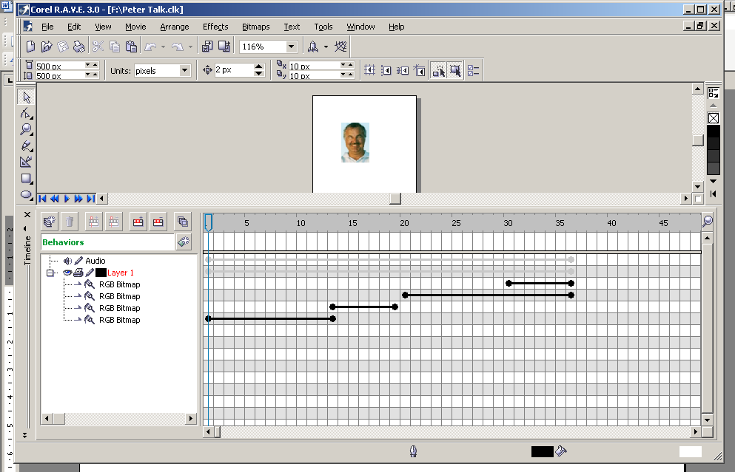
Drag copies of your image along the time line

Insert jaw2 at the end of this first timeline.

Insert jaw3 at the end of this next timeline.

Click on play

Importing Audio

Open Audacity or your audio program

Create sound using microphone or CD

Export as .WAV
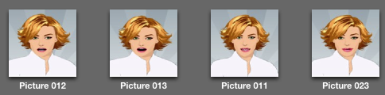
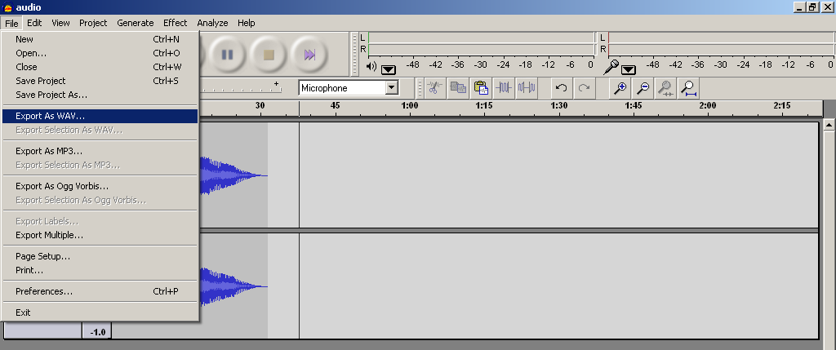

Import into RAVE (play twice to run audio)

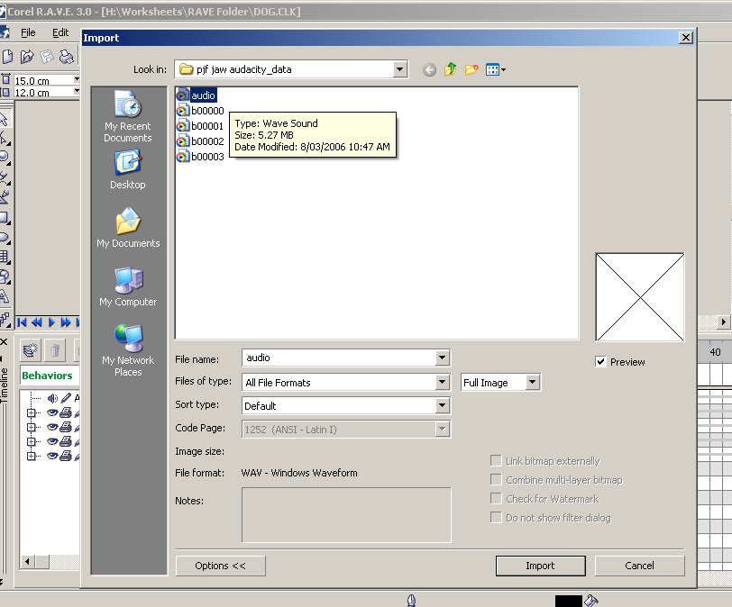

Exporting RAVE files

Go to File
Export

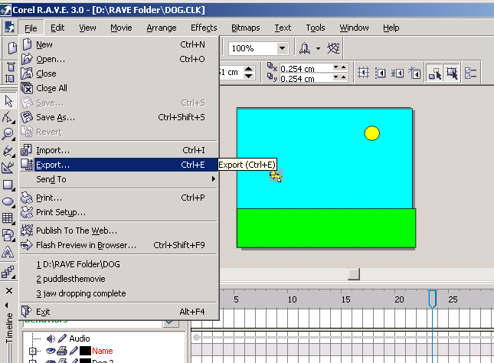

Choose
AVI – Video for windows
Compressed
Click on Export

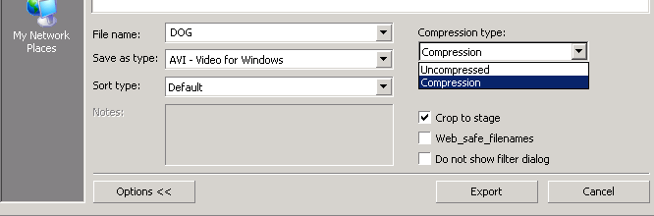
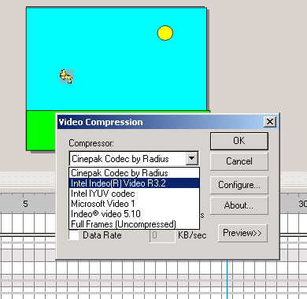
Select Intel Indeo Video R3.2
Click O.K.

You can now insert Movie into Power Point or other media programs.

Open with Quicktime

Record your audio

Import your audio into quicktime

Make your jaw talk…(Using Photoshop & Flash)

- Use Photoshop to open a photograph of yourself, use the lasso to select a part of your jaw

- Save this as yourname1.jpg

- Repeat creating at least 3 jaw movements saved as yourname1.jpg, yourname2.jpg, yourname3.jpg, yourname4.jpg etc.

- Drag this down and fill the gap with black or a dark pink or grey

- Save this as yourname2.jpg,

- Repeat bringing the jaw down further (use the same fill)

- Save this as yourname3.jpg

- Remember you can use Warp Tool in the Filters Liquify section

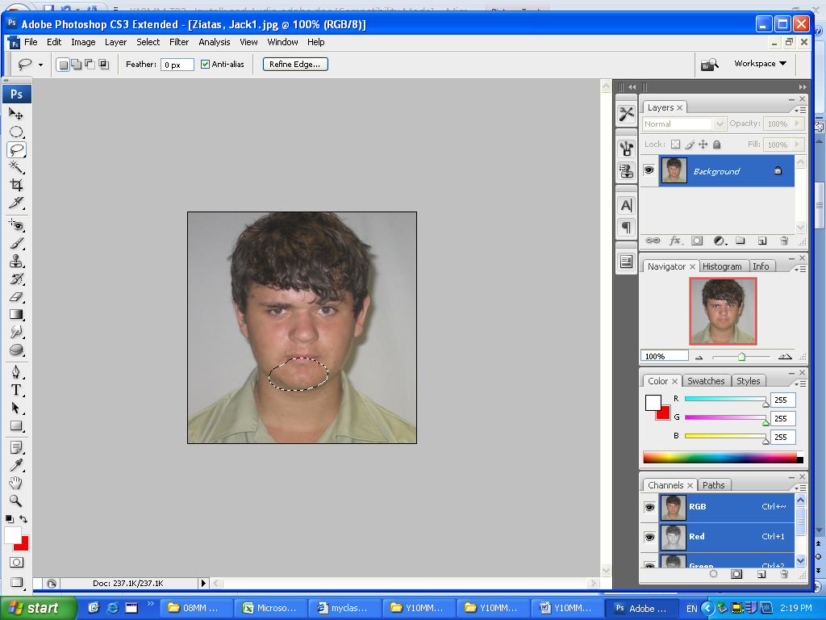

- Open Flash

- Import jaw images to library
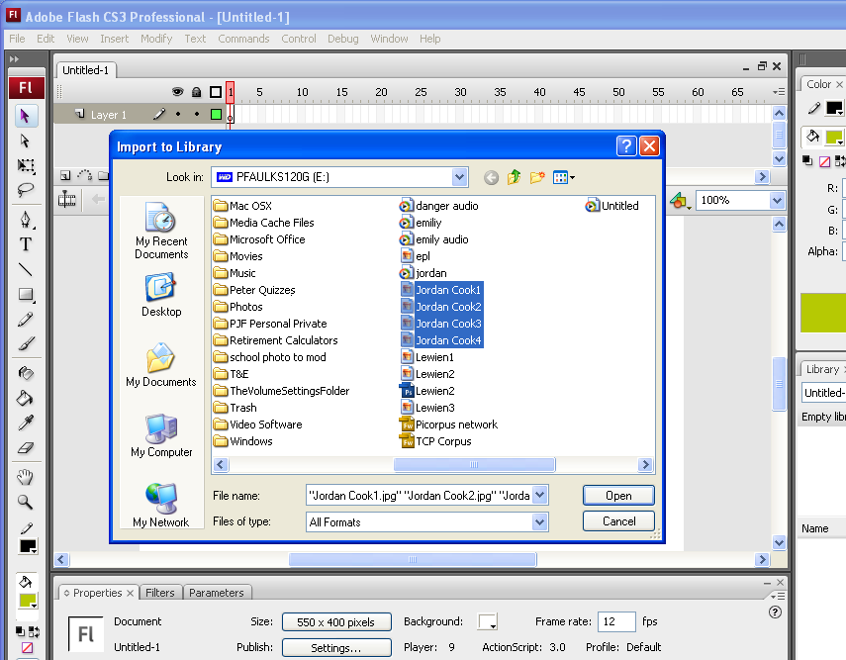
- Drag yourname1.jpg from the Library and place it into the centre of the stage
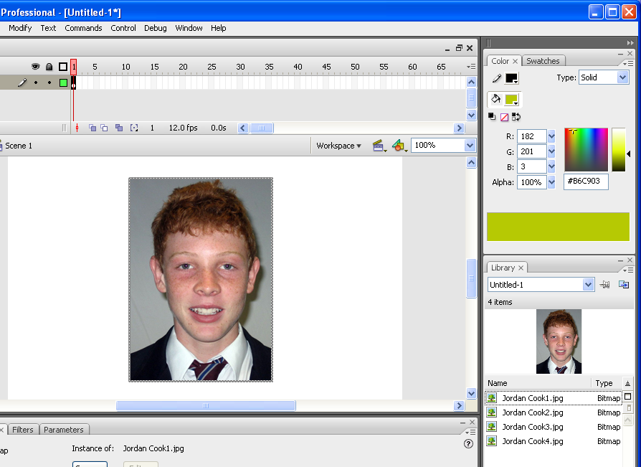

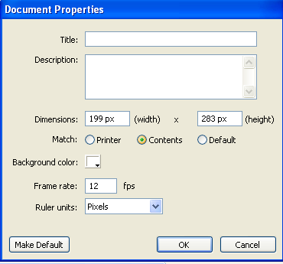
Modify Document to fit contents

Add each jawtalk after adding a key frame after two after two or three frames (Right Mouse)
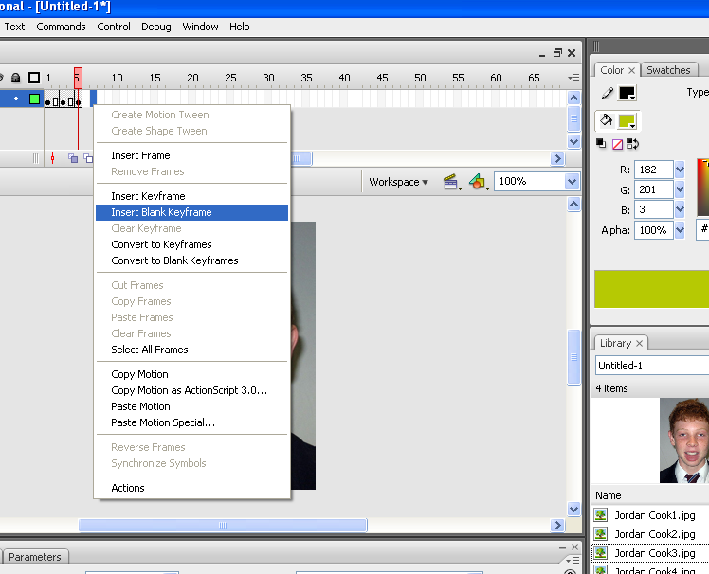

Drag copies of your image onto the stage

Insert yourname 2 at the end of this first timeline.

Insert yourname 3 at the end of this next timeline.

Copy frames to make a long speech

 |  |  |  | 

Click on play to test your jaw moves

Importing Audio

Open Audacity or your audio program

Create audio “hi my name is ;;;;;; welcome to my Multimedia portfolio” using microphone add additional background music from MP3 or CD or some sound FX from the shared drive.

Export as WAV

Importing into Flash make sure the Timeline is at the beginning of the movie.

FLASH
Import images to Library and create your Flash jaw talk and add sound track
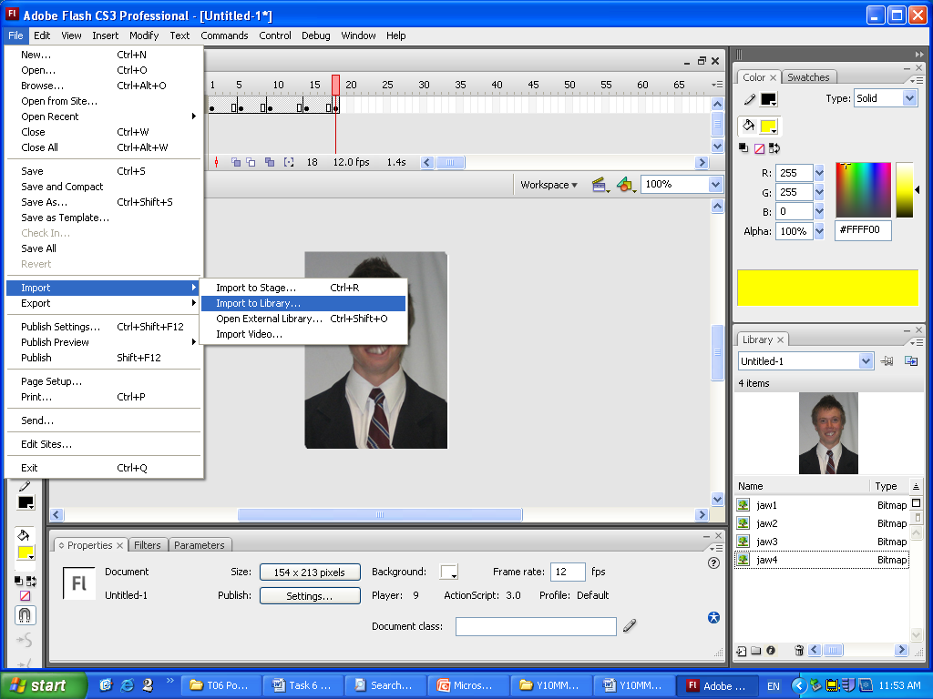

Add the sound files (Import to Library)
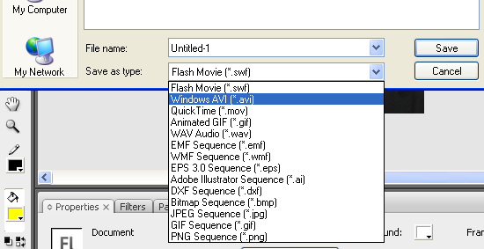
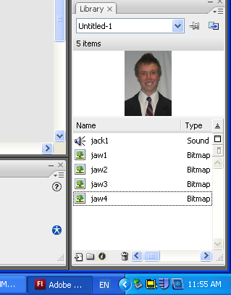
Ensure your movie matches the jaw talk and Export your movie as windows AVI

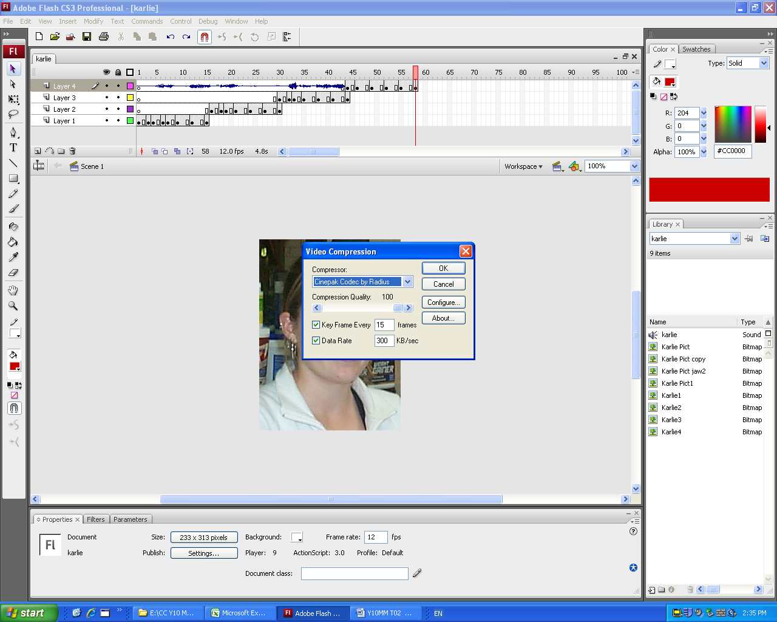

In Export Windows AVI click O.K.
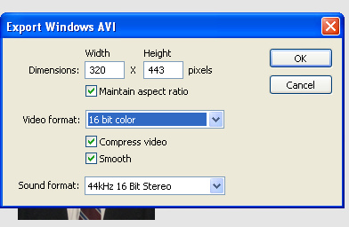
Set Video compression to Cinepack Codex

Import into Power Point

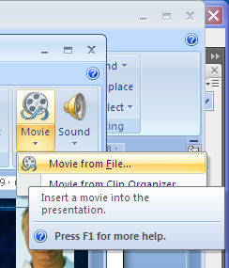
Insert Movie you should see an image of your face.
NOTE: (If you get a black screen go back and export your movie correctly!)

Click play Automatically.

Multimedia Task 2
Marking Grid Part 1 Jaw Talk
The Technology Process (Concept diagram) 50 Marks

Item Assessment Sheet | Possible  Mark | Actual  Mark
Investigating Software to use | 5
Devise plan your short speech  - On A4 plain paper plan what you will say | 5
- Annotate your plan with jaw actions | 5
- Apply a graphic context or theme to the plan | 5
Producing  - Create the jaw talk using software | 10
- The jaw should synchronize with words | 5
- Animation is smooth | 5
Evaluation Evaluate your efforts  - Provide evidence of your work in the form of a Power Point Portfolio  - Complete the Product, Process and Self evaluations | 10
Total | 50

Teacher Comment:

- Jaw Talk plus walk The Dog worksheet (If used)

Indicate Level
Animation of Jaw | 1 | 2 | 3 | 4 | 5 | 6 | 7 | 8 | 9 | 10
Jaw talks
Images used (3)
Animation repeated
Audio Balanced to mouth
Walk The Dog
Use of Images
Key frames Used
Action onion skins
Dog Jumps
Text added

Outcomes Assessed

Tech Process | L4 | L5 | L6
Investigating | Examines the values and beliefs of both the developer and user related to IT. | Determines the appropriateness of IT; considers communities and environments. | Investigates and explains how the design, production and use of IT are affected by human & environmental needs.
Devising | Generates designs that take into account society & environment; uses a range of images, models and technical terms. | Creates and prepares design proposals; includes options and reasons for choices; uses images to visualise ideas and realise designs. | Creates and prepares design & production proposals; examines a range of options; considers functional, aesthetic, social and environmental issues; uses subject-specific graphics and technical languages.
Producing | Organises and implements own production processes; works within constraints; recognises hazards; adopts safe work practices. | Organises and implements production processes to own specifications, recognises hazards and adopts safe work practices. | Organises, implements and adjusts processes based on detailed plans; describes using suitable technical languages and conventions; achieves defined standards of quality and safety.
Evaluating | Assesses how well the ideas, products, systems, processes, services and environments used meet design requirements, considers social and environmental effects. | Assesses the effectiveness of own designs, products, systems, processes, services and environments in relation to design requirements; considers social and environmental criteria. | Assesses own products, systems, processes, services and environments according to specified design requirements, including ethical criteria and comparisons with similar technologies.
System | L4 | L5 | L6
The use of systems | Controls and maintains simple linear systems; variety of means; uses taught techniques; applies knowledge of the elements to selection, control and testing. | Explores and operates a range of non-linear systems and their sub-systems. | Efficiently manages and controls non-linear systems & sub-systems; considers social and environmental impacts of decisions in meeting short & long-term needs (individuals and wider community)

Information | L4 | L5 | L6
The nature of information |  Understands that information is used, created, constructed, presented, stored and transmitted in different ways for particular audiences. |  Understands that there are specific forms, structures, styles and presentations used in particular IT products & processes. |  Understands that forms, methods of transmission, standards and conventions affect the use and impact of information.
Materials | L4 | L5 | L6
Students apply organisational, operational and manipulative  Skills appropriate to using developing and adapting technologies. |  Applies skills, organises resources, recognises hazards and operates tools and equipment efficiently and safely to the requirements of own design when creating and modifying technologies. |  Selects techniques and resources, manages the environment, organises and operates tools and equipment, considering personal limitations when creating and modifying technologies accordingly. |  The student selects techniques and resources; organises and efficiently operates tools and equipment, considering the requirements of own design, achieving defined standards of quality and safety when creating and modifying technologies.
Peter Faulks 2006

Evaluation Individual Task

Self-Evaluation Form - Audio

You have recently been working on an audio task.
Your next part is to honestly evaluate your own performance, your peers performance if in a group and your overall personal or group performance. This evaluation will assist in the determination of some of the course outcomes. It is a confidential evaluation and you’re your teacher will read it.

Task Title: Jaw Talk Task Number: 2

Your Name: Date Submitted:

List down all the tasks that you have completed during the investigation of your task

List the outcomes that you believe you have covered in this task

Devising

How did you plan this?

What audio software did you use

Investigating

What Investigation did you undertake (Copyright) Include your references from any web search.

Evaluating

What worked best: i.e. Audio importing

Audio mixing

Adding Effects

Exporting

Adding Voice

What worked worst:

How could you improve:

Producing

What did you do?

List down any of the new skills you have learnt while undertaking your task

Reflect on the process that you have gone through since commencing your task, write about any successes or problems you have personally encountered. (focus on yourself only).

Rate yourself on the following criteria

TEE subjects
(V outstanding, H very good, S satisfactory ND not demonstrated)

Whole School Select a level (4, 5 or 6)
For each box  Rate Your score in each based on the following: | Low Satisfactory High
 | 1 | 2 | 3 | 4 | 5 | 6 | 7 | 8 | 9 | 10

- Ability to locate information & research without any assistance
- Shows initiative
- Leadership/Planning Qualities
- Application to the task
- Time Management
- Works without any ‘nagging’ from the teacher

Did you personally enjoy investigation of your task?

- Yes
- No

What are some things you liked about this task?

What are some things you disliked about this task?

Any other comments you would like to make?

